Объем кроны голубики сорта «Блюкроп» удобряемой методом еженедельной фертигации, 3-х разовой фертигации и 3-х разового внесения гранулированных удобрений (поливаемых через кап.трубку и микроспринклерами) с объемами внесений 0, 50, 100 и 150 кг/га N
Canopy cover of “Bluecrop” blueberry fertilized by weekly fertigation, split fertigation, or granular fertilizer (irrigated by drip or microsprinklers) applications at 0, 50, 100, and 150kg·ha⁻¹N. Each symbol represents the mean of six replicates and error bars represent 1 SE.

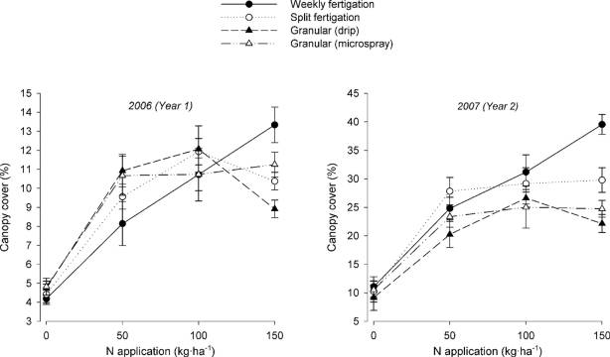

Доля погибших растений голубики сорта «Блюкроп» удобряемых...
Proportion of dead “Bluecrop” blueberry plants fertilized by weekly fertigation, split fertigation, or granular fertilizer (irrigated by drip or microsprinklers) applications at 0, 50, 100, and 150kg·ha⁻¹N. Dead plants were counted in October 2006. Each bar represents the mean of six plots and error bars represent ±1 SE.
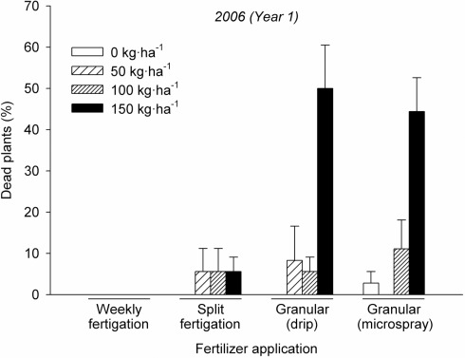
Концентрация азота в листьях голубики….
Leaf N concentration of “Bluecrop” blueberry fertilized by weekly fertigation, split fertigation, or granular fertilizer (irrigated by drip or microsprinklers) applications at 0, 50, 100, and 150kg·ha⁻¹N. Each symbol represents the mean of six plots and error bars represent ±1 SE.
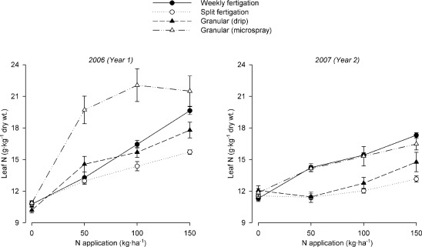

Концентрация азота в аммонийной форме в образцах суспензий почвы, взятых с посадок голубики Блюкроп….
Ammonium–nitrogen (NH₄–N) concentrations in soil solution samples collected from “Bluecrop” blueberry fertilized by weekly fertigation, split fertigation, or granular fertilizer (irrigated by drip or microsprinklers) applications at 0, 50, 100, and 150kg·ha⁻¹N. Solution was collected periodically from the root zone during the second growing season (2007). Each symbol represents the pooled average of six plots.
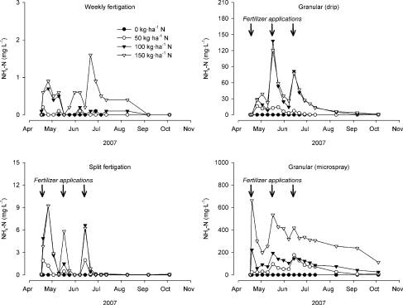
Концентрация азота в нитратной форме в образцах суспензий почвы, взятых с посадок голубики Блюкроп….
Nitrate–nitrogen (NO₃–N) concentrations in soil solution samples collected from “Bluecrop” blueberry fertilized by weekly fertigation, split fertigation, or granular fertilizer (irrigated by drip or microsprinklers) applications at 0, 50, 100, and 150kg·ha⁻¹N. Solution was collected periodically from the root zone during the second growing season (2007). Each symbol represents the pooled average of six plots.
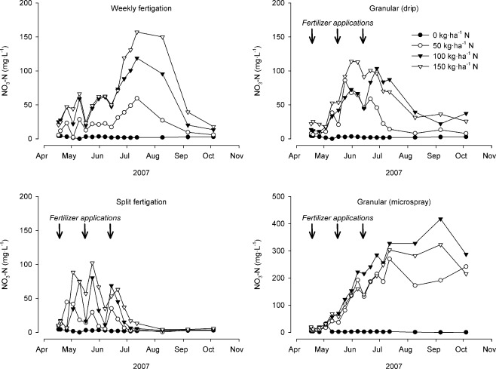
Электропроводность образцов почвенных суспензий, взятых….
Electrical conductivity of soil solution samples collected from “Bluecrop” blueberry fertilized by weekly fertigation, split fertigation, or granular fertilizer (irrigated by drip or microsprinklers) applications at 0, 50, 100, and 150kg·ha⁻¹N. Solution was collected periodically from the root zone during the second growing season (2007). Each symbol represents the mean of three pooled plots.
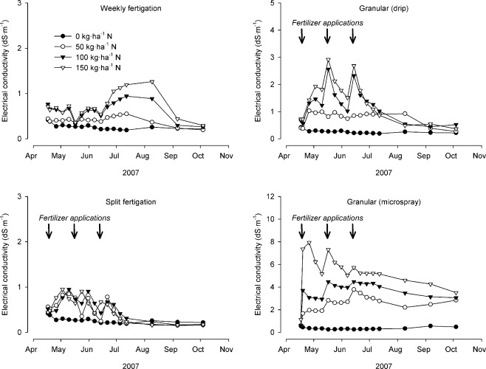
рН грунта на опытных участках…
Soil pH in plots of “Bluecrop” blueberry fertilized by weekly fertigation, split fertigation, or granular fertilizer (irrigated by drip or microsprinklers) applications at 0, 50, 100, and 150kg·ha⁻¹N. Soil samples were collected and analyzed for pH during the second growing season (2007). Each symbol represents the mean of three pooled plots and error bars represent ±1 SE.

